Sales of products in four different regions is tabulated for males and females. Find if male-female buyer rations are similar across regions.

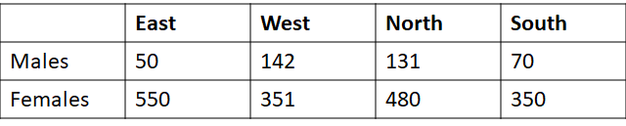

Ans:

Steps for Hypothesis testing

1. Define Null and Alternate hypothesis testing :

H0: Male-Female buyer ratio is similar across region

Alternate Hypothesis

H1: Male-Female buyer ratio is NOT similar across region

1. Identify the test statics to be used for testing validity of Null hypothesis

(Chi-square test)

chi2_contingency(Buyer_df)

==>(1.595945538661058,

0.6603094907091882,

3,

array([[ 42.76531299, 146.81287862, 131.11756787, 72.30424052],

[ 442.23468701, 1518.18712138, 1355.88243213, 747.69575948]]))

1. Significant value(Alpha) to be considered as 0.05
2. Calculate critical value [If the calculated Chi-square(1.59) is greater than the

critical value(7.81) we reject the null hypothesis.]

1. Take the decision to reject or accept Null Hypothesis based on Chi-square and

Critical value

Here Chi-square(1.59) & critical value(7.81)

Accept Null Hypothesis